**Introduction to Data Mining**

**Overall Word Count (reading and tasks) ______ (no more than 3000)**

Learning Goals

* **Define and discuss data mining and concepts of data mining**
* **Discuss common data mining techniques to gain insight and reveal trends and patterns**
* **Gain understanding of what industries use data mining and for what purposes**
* **Conduct some basic data mining - cluster analysis**

Introduction

What data mining actually is can be confusing if you are just starting out learning to be a data analyst. When you think of gold mining, you might imagine a large operation with people using pickaxes and machines to dig into the dirt and apply various techniques to identify the gold and separate it from the rest of the dirt. The objective of gold mining is to find gold, of course! But with data mining the objective is not to find data.

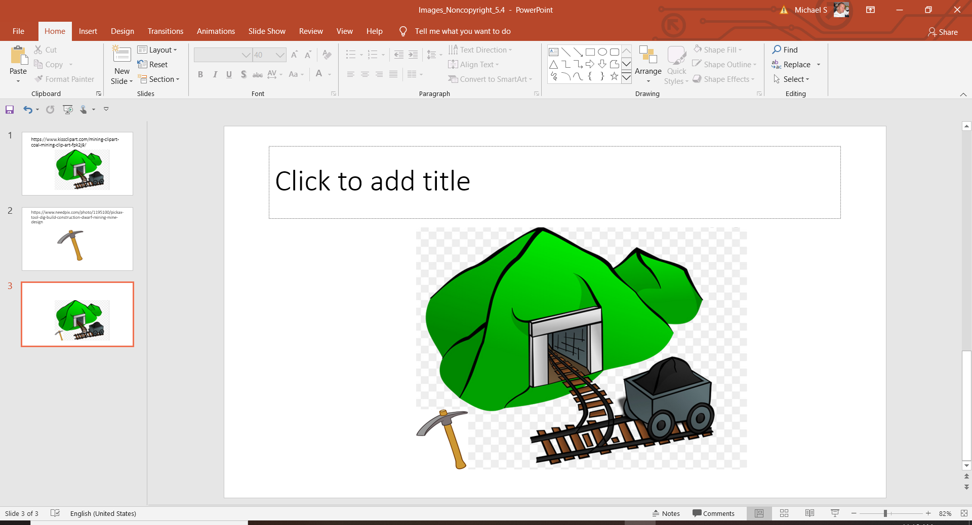

Data Privacy

Case Studies

Adobe

Equifax

Heartland Payment Systems

Data Security

Data Collection

Data Ethics Scenarios

Summary

Resources

Images